ASSIGNMENT 1: .NET browser tutorial ( from Microsoft C# tutorial website )

ASSIGNMENT 2: Assignment on numbers ( data types and operations on data type ) and on branches and loops.

CODE :

using System.Runtime.CompilerServices;

internal class Program

{

private static void Main(string[] args)

{

void fibb(int n)

{

int a = 1;

int b = 1;

Console.Write(a + " " + b);

Console.Write(" ");

for (int i = 0; i < n - 2; i++)

{

int c = a + b;

Console.Write(c + " ");

a = b;

b = c;

}

}

void fact(int m)

{

int ans = 1;

for (int j = 1; j <= m; j++)

{

ans = j \* ans;

}

Console.Write(ans);

}

static void permutation(String a,

int l, int r)

{

if (l == r)

Console.WriteLine(a);

else

{

for (int i = l; i <= r; i++)

{

a = swap(a, l, i);

permutation(a, l + 1, r);

a = swap(a, l, i);

}

}

}

static String swap(String z,

int i, int j)

{

char temp;

char[] charArray = z.ToCharArray();

temp = charArray[i];

charArray[i] = charArray[j];

charArray[j] = temp;

string s = new string(charArray);

return s;

}

int num;

do

{

Console.WriteLine("select 1.Fibbonaci 2.Factorial 3.Permutation & Combination 4.exit");

num = Convert.ToInt32(Console.ReadLine());

if (num == 1)

{

Console.Write("How many numbers of series you want : ");

int fib1 = Convert.ToInt32(Console.ReadLine());

Console.Write("Fibbonaci series of " + fib1 + " terms is : ");

fibb(fib1);

}

else if (num == 2)

{

Console.Write("What numbers factorial you want : ");

int fac1 = Convert.ToInt32(Console.ReadLine());

Console.Write("Facortial of Number " + fac1 + " is : ");

fact(fac1);

}

else if (num == 3)

{

Console.Write("Write digits whose permutation you want : ");

string a = Console.ReadLine();

int x= a.Length;

Console.WriteLine();

permutation(a, 0, x - 1);

}

Console.WriteLine();

Console.WriteLine();

} while (num <= 3);

} }

OUTPUT :

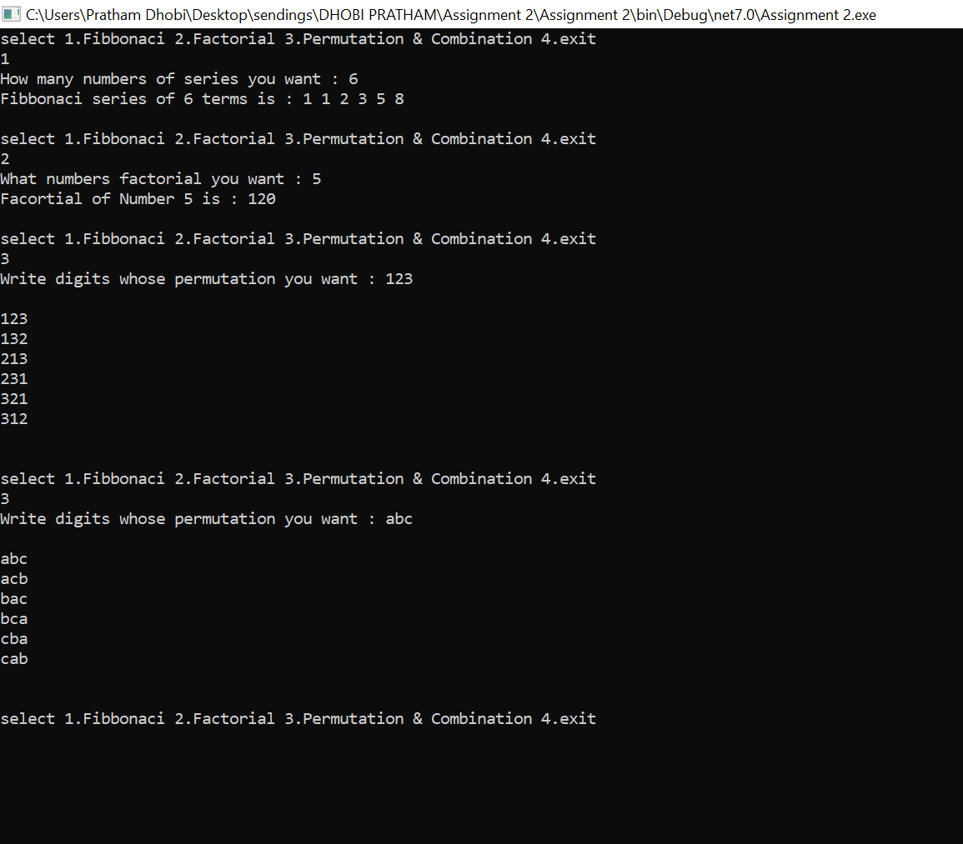

ASSIGNMENT 3:

Question 1. Rational number calculator (to calculate the floating point division, quotient, remainder, and mixed fraction of two integers.)

CODE :

using System;

using System.Numerics;

namespace HelloWorld

{

class Program

{ static void Main(string[] args)

{ Console.Write("Please enter the numerator : ");

int nume = Convert.ToInt32(Console.ReadLine());

Console.WriteLine();

Console.Write("Please enter the denominator : ");

int deno = Convert.ToInt32(Console.ReadLine());

Console.WriteLine();

int res1 = nume/deno;

float res2 = (float)nume /(float) deno ;

int remen = nume - (res1 \* deno);

Console.WriteLine("Integer division result = "+res1+" with a remainder "+remen);

Console.WriteLine("Floating Point Division result = "+res2);

Console.WriteLine("The result as a mixed fraction is : "+res1+" "+ remen+"/"+deno);

Console.ReadLine();

} } }

OUTPUT :

